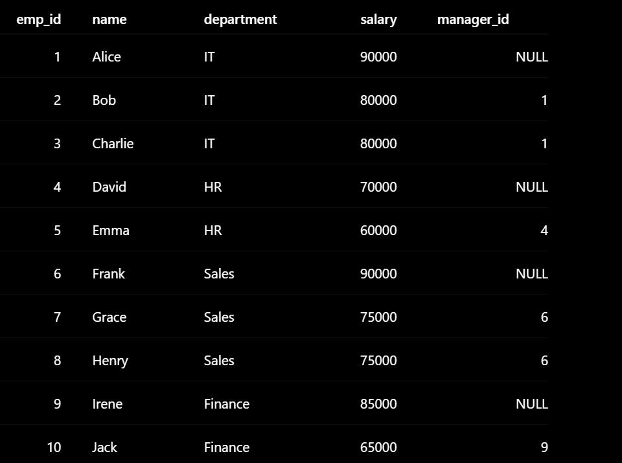
Highest Salary


Second highest salary

2. Find the Nth highest salary
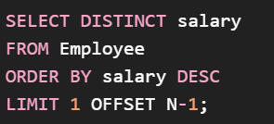
OFFSET means:
Skip this many rows before returning the result.

5. Find the highest salary in each department

Find employees earning more than the average salary





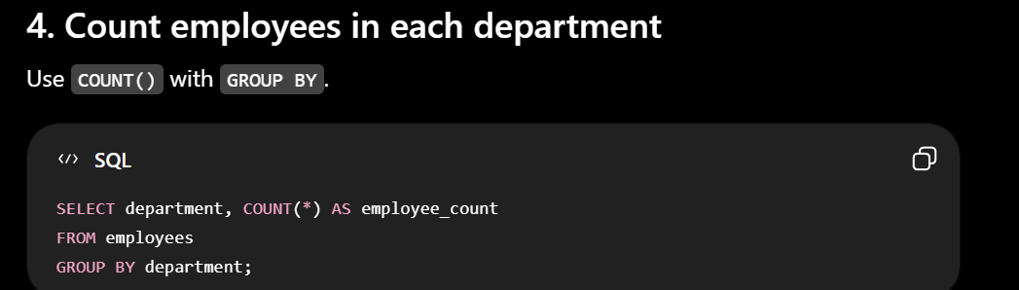
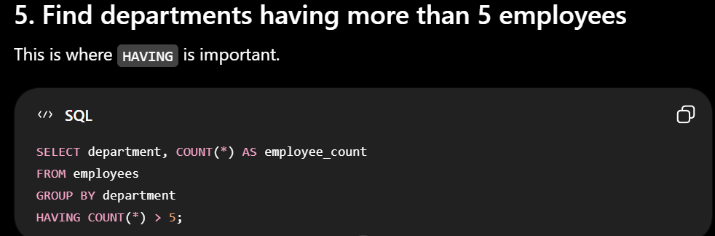
14. Find the total salary of each department

11. Find the top 3 highest-paid employees

3. Find duplicate records
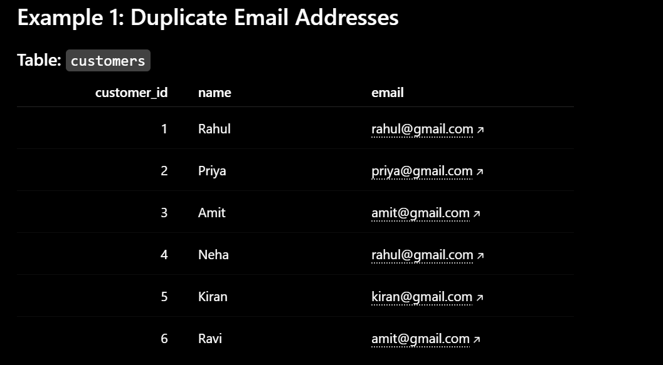



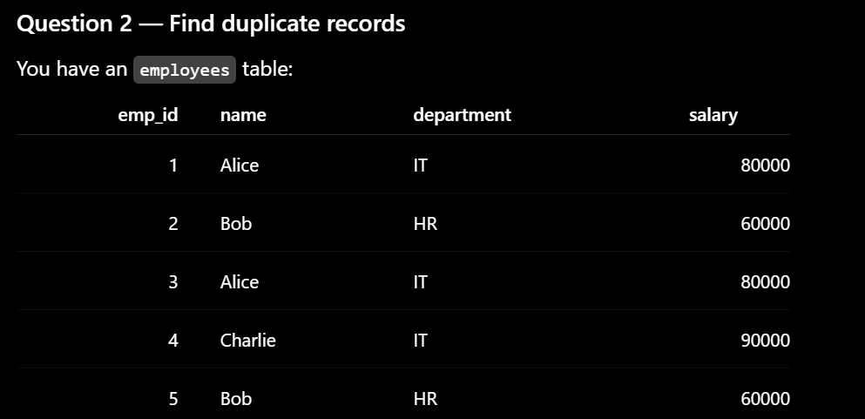

4. Find employees who have no manager

1. Find employees who don't belong to any department
\]
- Find customers who never placed an order
- LEFT JOIN + IS NULL ⭐

16. Find employees who earn the highest salary in each department ⭐

17. Find departments with no employees


18. Find customers who placed more than 3 orders


